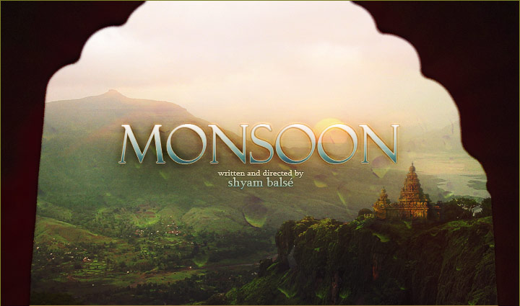

Tag Line

There is a season in every man’s life…
…when he must return home…

Log Line

Govinda, a California doctor, is forced to return to his motherland in India when his estranged father falls ill. When Govinda tries to administer treatment, his father has other plans that send both of them on a journey into their pasts to try and reconcile their broken relationship before time runs out.

Synopsis

Mumbai, India -- Present Day. The sweltering dead heat of the Indian summer. The only hope for relief are the elusive monsoon rains, already 3 weeks delayed. Into this sweaty inferno comes Govinda, a hotshot Californian Cardiologist and atheist who has journeyed back to his native country to treat his father's ailing health. Govinda despises India almost as much as he does his father who embraces it. It is dirty, disorganized, superstitious and the place where his beloved wife was killed in a tragic accident. Much to his frustration, his father, a devout Hindu Brahmin and the hard headed patriarch of the family, refuses medical treatment claiming that only God can heal him. As the tension between father and son grows, Govinda gets drawn back into the mystery surrounding his wife's death stirring up old skeletons that threaten to split the family apart forever.

About the Film

MONSOON is a 20 minute film shot on location in and around Mumbai, India. It was made as part of the graduate film production program at the University of Southern California by graduates Shyam Balsé (writer/director) and Joseph Itaya (producer) under the faculty supervision of the chair of USC’s film production program, Michael Taylor (producer of Phenomenon and Bottle Rocket). It was shot over 8 days in early December 2005 using a primarily Indian cast and crew, many of whom work in the Bollywood film and television industry. Post production took place in Los Angeles, California and was completed July 2006.

The film stars a combination of new rising Indian talent and award winning Bollywood veterans. The lead role of Govinda is played by newcomer Bhanu Uday (Special Squad, Return to Rajapur) who only a few years before graduated from the top dramatic academy in India, the National School of Drama. The second lead is played by the great Ravi Baswani (Jaane Bhi Do Yaaron, Yun Hota To Kya Hota), a well known and loved character actor and director in India. The cast is rounded out with the supporting performance by one of India’s most respected and acclaimed Marathi actresses whose work appears in over 50 feature films, Sulabha Deshpande (Bhumika, Hech Majhe Maher, Akka)

The film was co-produced by Dileep Singh Rathore and his OTR Productions who produced the internationally acclaimed Maya (2001) and the Oscar nominated short The Little Terrorist (2004).

AWARDS AND FESTIVALS

AWARDS
Sonoma Valley Film Festival

BEST NARRATIVE SHORT FILM

Indian Film Festival of Los Angeles

Audience Award for BEST SHORT FILM

First Look Film Festival

BEST NARRATIVE FILM and BEST OVERALL FILM

Mendocino Film Festival

BEST NARRATIVE SHORT FILM

Breckenridge Festival of Film

BEST STUDENT FILM and BEST DIRECTOR

Jackson Hole Film Festival

BEST SHORT FILM DIRECTOR

Long Island International Film Expo
BEST FOREIGN FILM

OFFICIAL SELECTIONS
Palm Springs Festival of Short Films
LA Shorts Fest
Sedona International Film Festival & Workshop
San Francisco International Asian American Film Festival
Santa Cruz Film Festival
Newport Beach Film Festival
Winnipeg International Film Festival
Heartland Film Festival
Maui Film Festival
Wine Country Film Festival
Monsoon Festival 2
Asian Film Festival of Dallas
DC Meets Delhi Film Festival
Sun Valley Spiritual Film Festival
Independent South Asian Film Festival
San Diego Asian Film Festival
Indo American Arts Council Film Festival
Miami Short Film Festival
Beverly Hills Hi-Def Film Fest
Short Film Festival of India

CAST

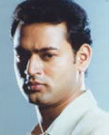  Bhanu Uday  “Govinda” | Bhanu Uday, a new rising star in the Bollywood film and television scene, recently graduated from India’s premier theatrical academy in New Delhi, the National School of Drama. Upon graduating in 2004 he moved to the heart of the Bollywood film industry in Mumbai, and landed a lead role on the popular television crime drama series, Special Squad. His first feature performance was a lead role on a soon to be released Hollywood-Bollywood co-production called The Man From Rajapur starring Lynn Colins and Kelli Garner. He is continuing to focus on feature film projects and has an eye to eventually move to the US and pursue his career in Hollywood. To help him make the crossover, Bhanu plays the lead role in MONSOON of Govinda, an Indian doctor living in California.
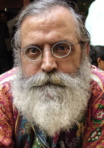  Ravi Baswani  “Baba” | Ravi Baswani, is a well known and respected character actor who has appeared in dozens of Bollywood films. He won the Filmfare Award (India’s Oscars) for his role in Kundan Shah’s “Jaane Bhi Do Yaro” (1983) and was nominated 3 times for his first 3 films. He also has a successful career as a television producer and director and maintains a special interest in directing children’s theater. Ravi has recently written a children’s feature film that he has just been green lit to direct. While known primarily as a comedic actor, Ravi shed his humorous side to play the serious role of Baba, the hardheaded family patriarch in MONSOON.

CAST

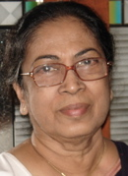  Sulabha Deshpande  “Sita” | Sulabha Deshpande is by all means a veteran in the field of acting; having been honored with nearly 30 major awards including the National Award for Theatre, the Maharashtra Gaurav award, the Sangeet Natak award etc, acted in over 50 Indian films including an appearance in Mira Nair’s Salaam Bombay (1988). She is also an accomplished director and devotes much of her time these days to children’s theater. Sulabha was generous enough to lend a small but stellar supporting performance as Govinda’s loving Auntie, Sita in MONSOON.

CREW

Shyam Balsé  Writer/Director | Although born to an Indian father and Anglo mother Shyam is a true California boy at heart. While born in Nevada he spent most of his life growing up along the beautiful North Coast in Mendocino, California. After earning a BA with highest honors in Socio-Cultural Anthropology and graduating Magna Cum Laude from UC San Diego, Shyam moved to Los Angeles to make a life in the television and film industry. Since then he has written and produced dozens of hours of programming for Paramount Television, Travel Channel, Discovery Channel, TLC, Animal Planet and other Discovery Networks. He's also had the opportunity to work with top Hollywood talent such as Robert Zemeckis, and recently produced a feature mockumentary with his wife Leslie Zemeckis. Shyam recently graduated from the Film Production Program at the School of Cinema-Television at the University of Southern California where he earned his MFA degree. Having traveled to India over a dozen times, this was his first film shot there.
Joseph Itaya  Producer | Joseph is a producer, director, and writer in Los Angeles, who recently received his MFA at the University of Southern California. During the past three years, Joseph has written and directed 14 short films, and is currently developing the feature film "Lost and Found". Before coming to film school, Joseph worked professionally as a pianist, conductor, and composer in the Seattle area. As a pianist, Joseph toured and performed in the United States, Russia, Ukraine, and Japan. Joseph has served as conductor of numerous orchestras, choirs, and musical groups. Joseph wrote the original score for the award winning documentary "Alone Against the Sea", as well as the script and music for the original musical "Kris Kringle". Joseph has many recordings to his credit, both as a singer/songwriter, instrumentalist, and producer. Joseph is the Executive Director of Tempered Entertainment, an LA based film and music production company. You can visit his company online at temperedentertainment.com

CREW

Dileep Singh Rathore  Producer | As the principle "India-side" producer, Dileep ran the production through his company On The Road Productions (OTR), a Production Services Company for international feature films, TV movies & series, commercial and music video projects shooting in India and South Asia. Over the last sixteen years Dileep Singh Rathore and the team at OTR Productions have worked on projects and assignments with renowned talent such as Directors John Boorman, Rolland Joffe, Mira Nair, Nicholas Meyer and Little X; Actors Pierce Brosnan, Kirk Douglas, Patrick Swayze, Elodie Bouchez and Writers such as Tom Stoppard and Toni Grisoni. As Producer, Dileep has produced the internationally acclaimed feature film, Maya (2001), the Oscar nominated, Little Terrorist (2004), Cannes Official Selection documentary Darshan (2004) and upcoming Arclight Films release of the American feature film Return To Rajapur (2005) currently in competition at the Tribeca Film Festival.
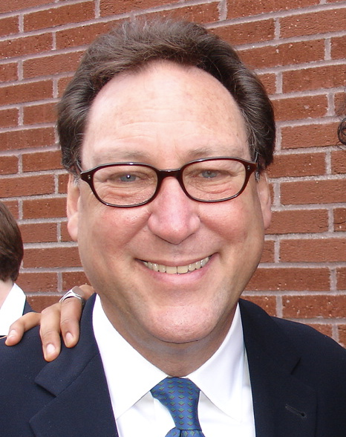  Michael Taylor  Faculty Mentor | Michael Taylor is a motion picture producer of theatrical and television films and currently serves as Chair of the Production Division at the University of Southern California School of Cinema-Television. He began his career as a Motion Picture Executive at United Artists Corporation, and served as UA's European Head of Production based in London. Having produced both within the studio system and in the independent film arena, his credits include INSTINCT, PHENOMENON, BOTTLE ROCKET, THE HI-LINE, LAST EMBRACE, THE PURSUIT OF D.B. COOPER, MRS. MUNCK, and PRINCESS OF THIEVES. Among other honors, he is the recipient of the Fourteenth Annual Genesis Award for Outstanding Feature Film, The Variety/EDI $100 Million Award, and is a member of The Academy of Motion Picture Arts and Sciences. Taylor received his Bachelor's Degree in Education from the University of Miami.

CREW

Mahaveer Shaktawat  Line Producer | Mahaveer graduated with a BA from the prestigious St. Xavier’s College, Bombay. He has Diplomas in 3D Animation and Cinematography. After graduating Mahaveer worked for Madison DNB&B as Production Executive later moving to Mercury Films as an Assistant Director on series productions for Sony & Zee TV. Mahaveer also worked as Agency Producer at Ammirati Puris Lintas before joining OTR Productions as Production Coordinator. Since joining OTR Mahaveer has worked on the features, Eight Miles High and Return To Rajapur in the capacity of 1st and 2nd Assistant Director and on campaigns for companies such as FedEx and the National Geographic Channel. Mahaveer heads the Mumbai office for OTR Productions.
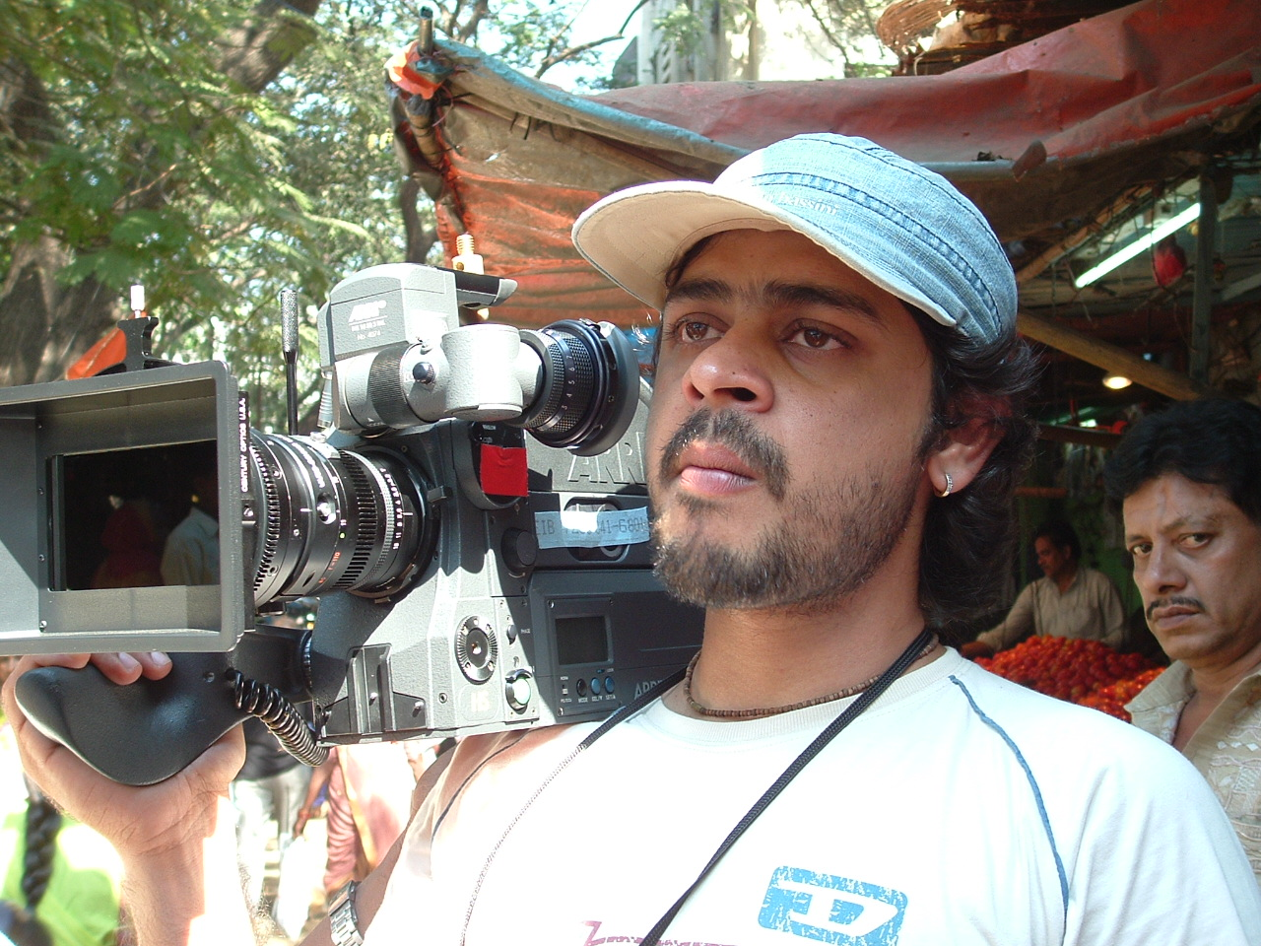  Vineet Malhotra  Director of Photography | Vineet is one of Bollywood’s up and coming young talented cinematographers. After having worked in all aspects of the camera department for years, and having the opportunity to gaff and be the 2nd Unit DP on a recent international feature film, MONSOON was Vineet’s first time as director of photography.
Abishek Redkar  Production Designer | Abishek has extensive experience working as a production designer on many of Bollywood’s top films. Recently he worked on the international hit film BRIDE AND PREJUDICE. He lives and works in Mumbai, India.

CREW

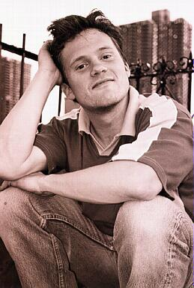  Tom Gould  Editor | Tom received his undergraduate degree from Vassar College in Poughkeepsie, NY, and his Masters in Fine Arts from the School of Cinema Television at the University of Southern California, where he was awarded the Jack Nicholson Scholarship for Excellence in Directing. As an editor, Tom has cut two feature films. The first was FREEZE OUT, directed by M.J. Loheed. The film won the Best Feature prize at the Westwood International Film Festival and was runner up for the Audience Choice award at the Omaha Film Festival. His next feature sent him down to Bogotá, Colombia, where he cut Ryan Byrne’s, Á COLOMBIA. The film won the Audience Choice Award for Best Dramatic Feature at both the 2006 Cinequest Film Festival and the 2006 Moondance Film Festival. In addition, Tom has edited numerous short films and has edited two music videos. One for Chinese superstar Lee Hom Wang, the other for Vietnamese phenom, Trish Trang. The video for Lee Hom's song, GAI SHI YING XIONG (HEROES OF EARTH) helped push Lee Hom’s latest album to number one on the Asian charts.
  Robert Hawes  Music | Robert attended Dick Grove School of Music in Los Angeles. He started working in recording studios in order to get free studio time for his band. Eventually he started writing, producing, and engineering more and more projects around town. He’s done records, movies, commercials, cartoons for most of the major labels like Universal, Dreamworks, Geffen, and Interscope. Recently He’s been concentrating on composing music for film and television.

Eric Lindsay  Music | Eric is an accomplished composer, musician and teacher in the Los Angeles area whose compositions have been commissioned and performed internationally. In addition to chamber and orchestral compositions, Eric has written commercial scores for musical theatre, film and television. Several of his works have been published and distributed through Peermusic and Theodore Presser Company. Eric has extensive experience as both an award-winning oboist, pianist ,and vocalist including performances with the Seattle Symphony, the Los Angeles Philharmonic, the Saratoga Chamber Players and the IU New Music Ensemble. Mr. Lindsay holds composition degrees from the University of Southern California (MM), Indiana University-Bloomington (BM), as well as studies at King’s College in London.

Production Stills

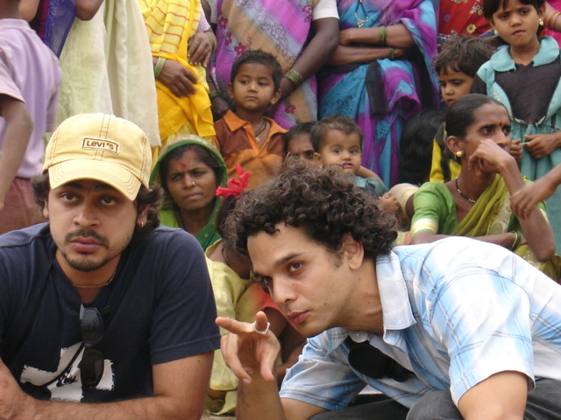

Director Shyam Balsé and Cinematographer Vineet Malhotra set the camera against a backdrop of colorful onlookers.

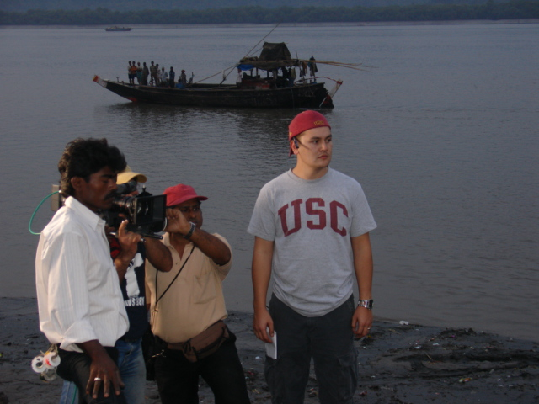

Producer and 1st AD Joseph Itaya stands close by as the camera team race the sun to get a shot off. In the background a fishing boat pulled up to watch the action.

Production Stills

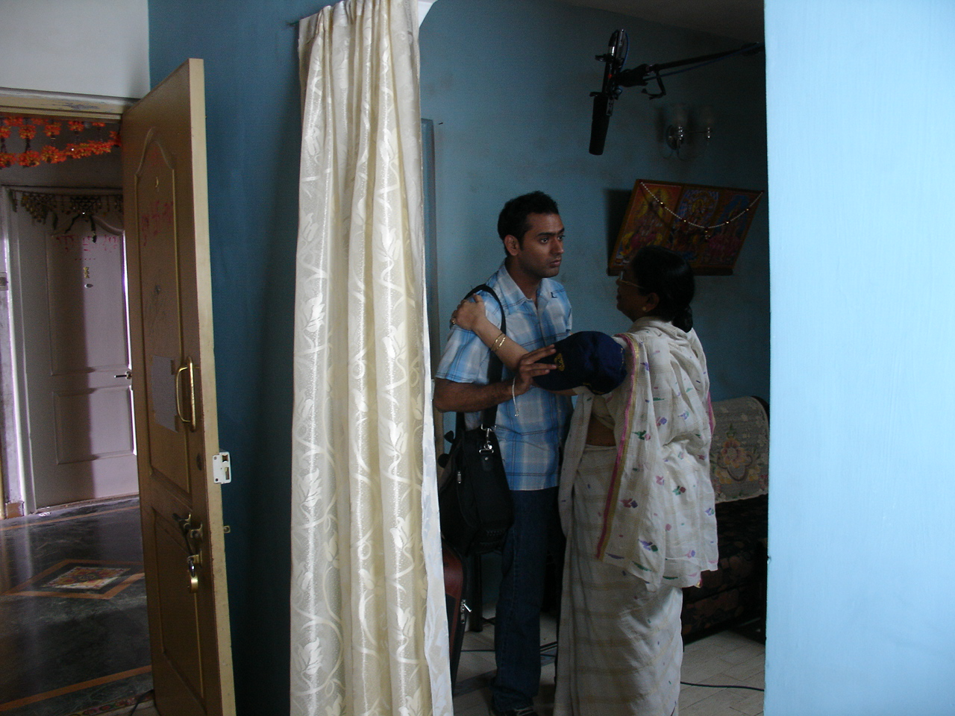

Bhanu Uday and Sulabha Deshpande filming a scene. We shot 3 days in this apartment that acted as both a live set and the rooming quarters for the crew.

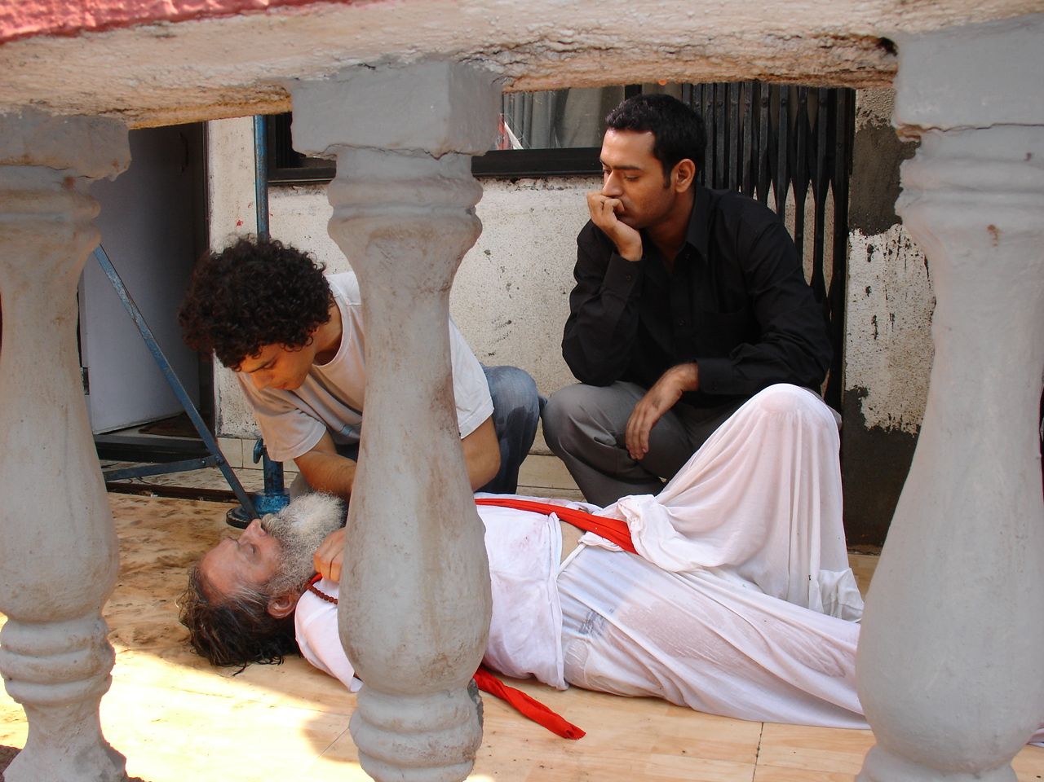
Shyam Balsé directs Ravi Baswani in the climactic scene of the film.

Production Stills

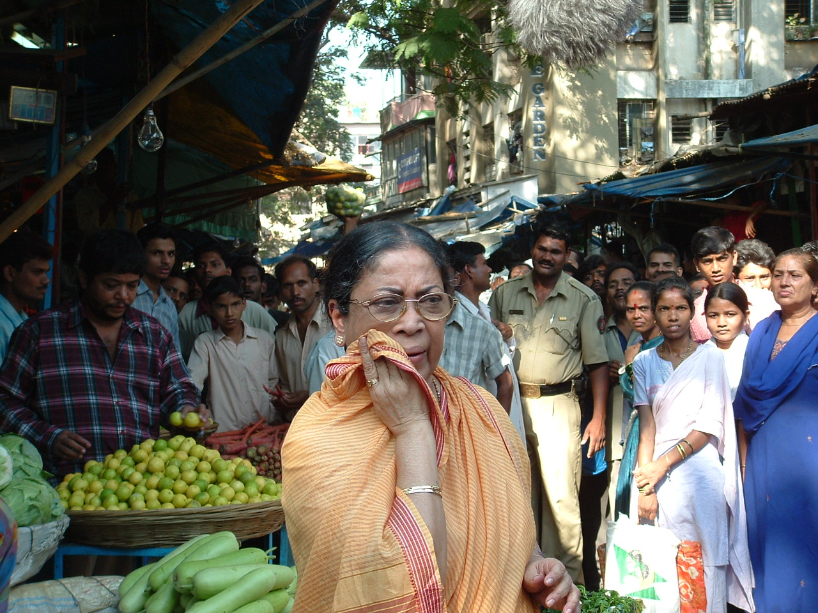
Sulabha Deshpande gets ready for her scene in the market. This was a live market full of people. In the background police helped control the massive crowds.

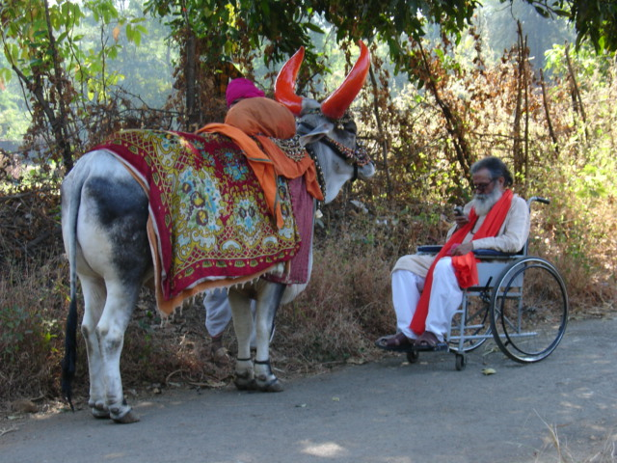
Ravi Baswani gets in character with his co-star, Gokul the bull. Gokul was not just any bull, he was a well trained movie bull used in many Bollywood features. And on top of that he is revered as a sacred animal in India.

Production Stills

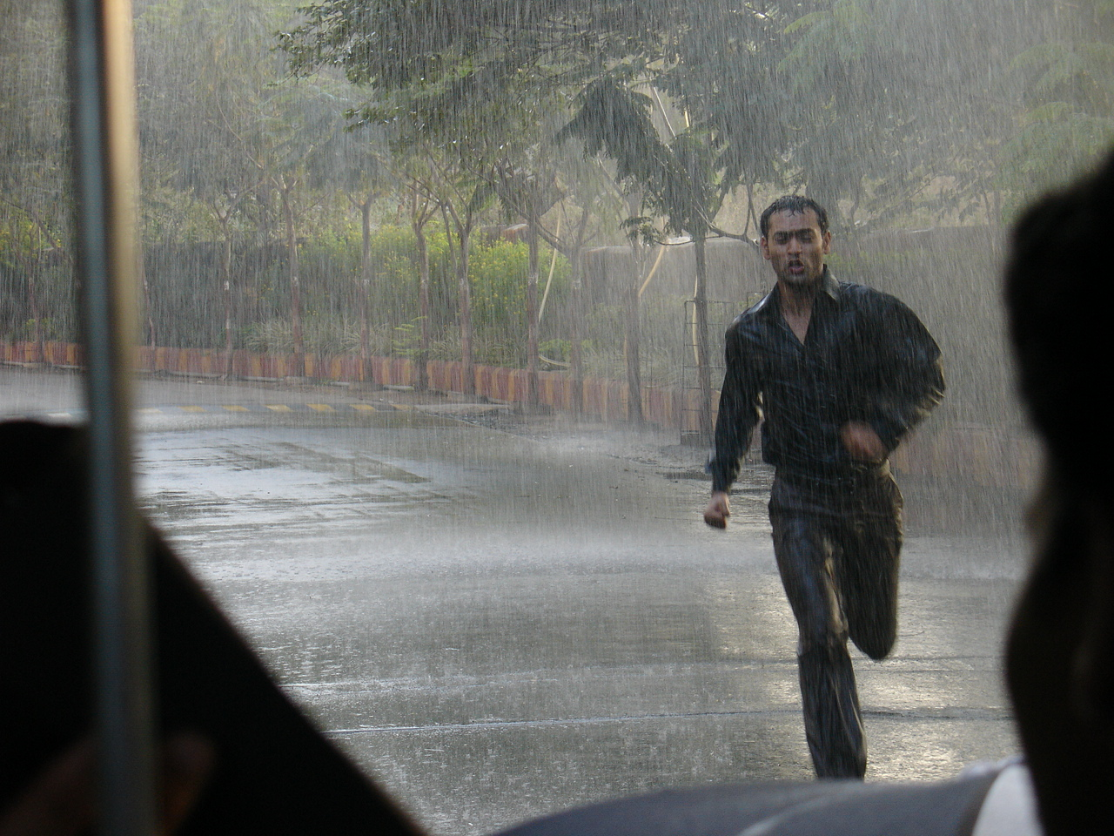
The namesake. Monsoon.

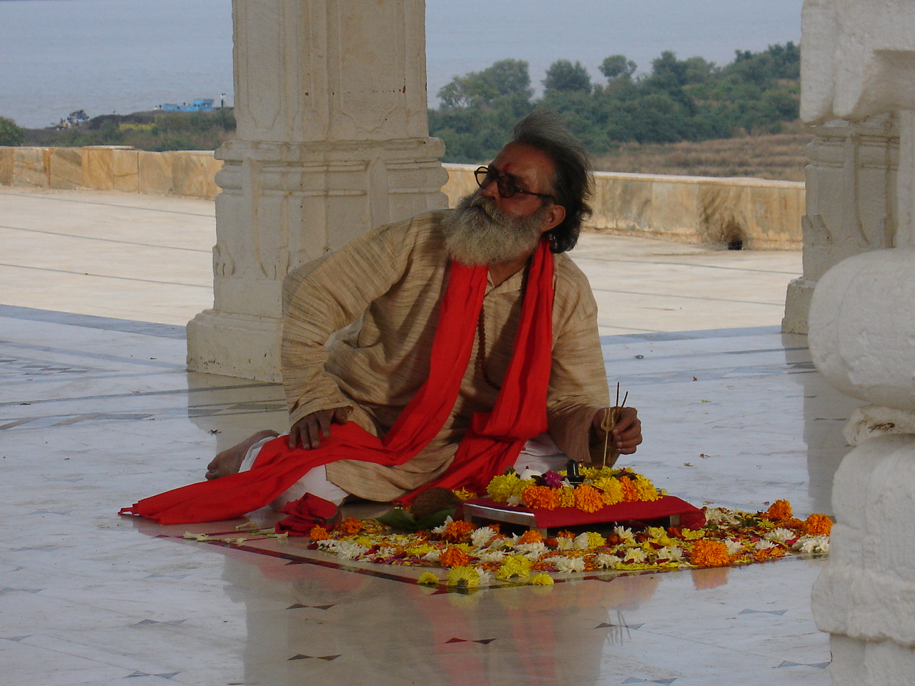
Ravi Baswani as “Baba” praying at the Hindu temple.

DIRECTOR’S STATEMENT

MONSOON is not an autobiographical story but it derives primarily from my intimate experiences traveling back and forth between India and the USA. Although I was born and raised in the States by my American mother, I’ve traveled back to India over a dozen times to visit my Indian father.

I’ve always been intrigued by how different the ‘West’ and the ‘East’ are in terms of philosophy, society, and religion. The two cultures are world’s apart, yet somehow I, and thousands of others like me, belong to and feel at home in both of them. To me, Eastern philosophy is so filled with chaos, magic, and mysticism which stands in stark contrast to the predominantly ordered, cold, and clinical outlook of Western Science. In MONSOON, I wanted to explore what happens when these two worlds collide within the same family.

I began writing the story in Spring of 2005 as my thesis film for the graduate film production program at the University of Southern California. I knew I wanted to shoot in India about something that I knew. Since I’ve spent a lot of time studying Eastern religions and know much about family life in India, and at the same time know first hand about growing up “American”, I decided to make a film about what happens when a young man, born in India yet identified with Western/Scientific thought, is forced to confront his ailing father who is very much a product of the Brahmin Hindu culture.

We shot the film over 8 days in Mumbai, India in December 2005. Most of the filming took place in and around where my father lived. We assembled a great cast and crew in India many of whom had experience in the Bollywood film industry. We also had a handful of American’s fly out to help as well. It was truly an international co-production and I am looking forward to making many more films in India.

ANECDOTES

All the location filming took place in live settings which always made our days exciting. India is known for it’s large curious crowds of people, and we quickly found out that they had plenty of time to sit and watch our shoot. At times we had 400-500 people standing around watching us usually dwarfing our film crew.

The market scene was by far the most challenging to shoot. It was a live, busy vegetable market. We had gotten permits from the city as well as 3 policemen to assist us, but neither seemed to help much. We couldn’t block off any area to shoot so we had to film right in the middle of the market with what seemed like thousands of people milling around us.

One sequence in particular required us to shoot wide shots of the crowd reacting to an accident in the market. We needed them to all look down and form a crowd around something on the ground as if somebody had been injured and they were all running up to see it. It was nearly impossible to prevent people from looking at the camera or to get them to move around as we needed, so we decided to use the crowd’s innately curious nature to our advantage.

We casually took the camera away and discreetly built it back up with a long lens on the far side of the market. Joseph Itaya, my producer and 1st AD, stayed around the area where we were shooting and kept the crowds attention by yelling and moving our extras around. After a few moments of this the crowd of onlookers lost track of the camera and focused on Joseph.

On a secret signal I rolled camera and then had Joseph duck down and start crinkling an empty bag of chips while calling for the crowd to come over and look (this worked despite the language barrier because people were so curious to see what he was up to). A crowd of at least 100 people swarmed around him jumping over each other to get a look. It was the perfect shot.

The best part was that we shot it 2 more time and each time the trick worked perfectly as the crowd would leap over each other trying to see what was going on. They never caught on that they had made the scene.

CONTACT

Mailing Address
835 N. Fuller Ave #13

Los Angeles, CA 90046

Shyam Balsé

C: 310.500.0473
shyambalse@gmail.com

Joseph Itaya
C: 323.252.6774
josephitaya@hotmail.com

www.monsoonfilm.com

